Arbor PBI Using the Report Templates

Introduction

ArborPBI.com
ArborPBI.com is the name I use for my ongoing Power BI project focused on Arbor schools, acting as a central place where I continue developing work in my spare time. It grew from the collaborative problem-solving culture on Arbor HQ, where many of us shared examples and ideas, and where great community work can still be found today. Recognising that many schools simply don’t have the time or resources to create resources themselves, I share these models and reports to make data more accessible and useful, because every student deserves to benefit from informed data decisions.


Contents
1. Introduction 2
1.1. ArborPBI.com 2
2. Importing and using the Bundled Reports 3
2.1. Edit the Data Source 4

Importing and using the Bundled Reports
When you import a report into Power BI, you will get the following error. This is expected as the report is trying to connect to its original dataset which you will not have access to. You will need to repoint it to your published dataset.
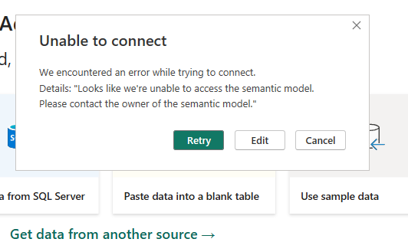

Edit the Data Source
When you see the above dialogue box, click on the Edit button and the OneLake catalog should open showing a list of all of the semantic models (datasets) you have published and have access to.
From the list shown, click on the one that represents the dataset that you previously published. It should become highlighted.
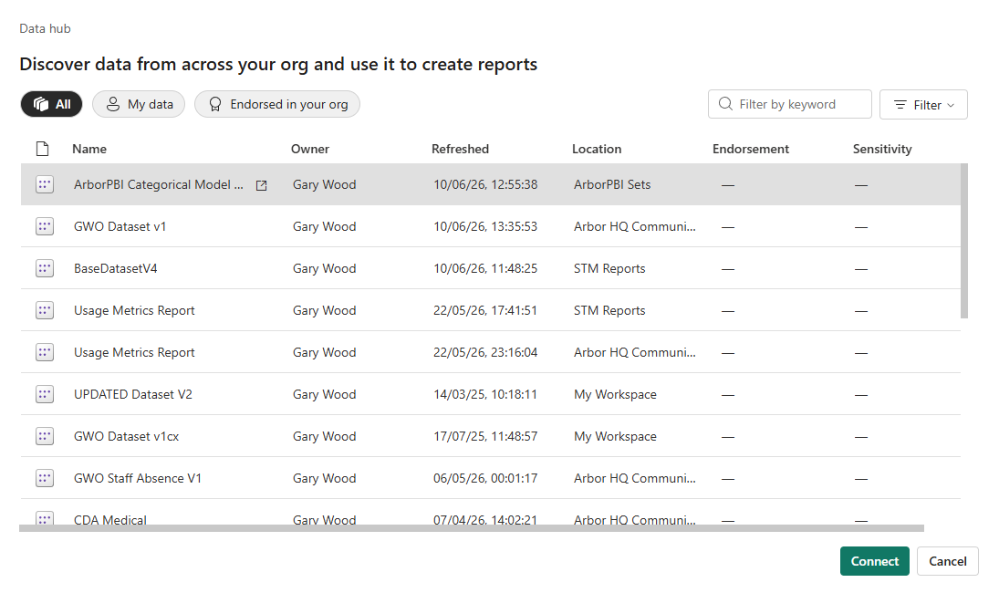

With the required dataset highlighted, click on the Connect button:
Once you have clicked on connect, if your dataset is working correctly, the report should load and display data. From this point you can then edit and tweak the report to meet your needs.

