Arbor PBI RC Attendance DfE Comparisons Report
Last Updated 29/06/2026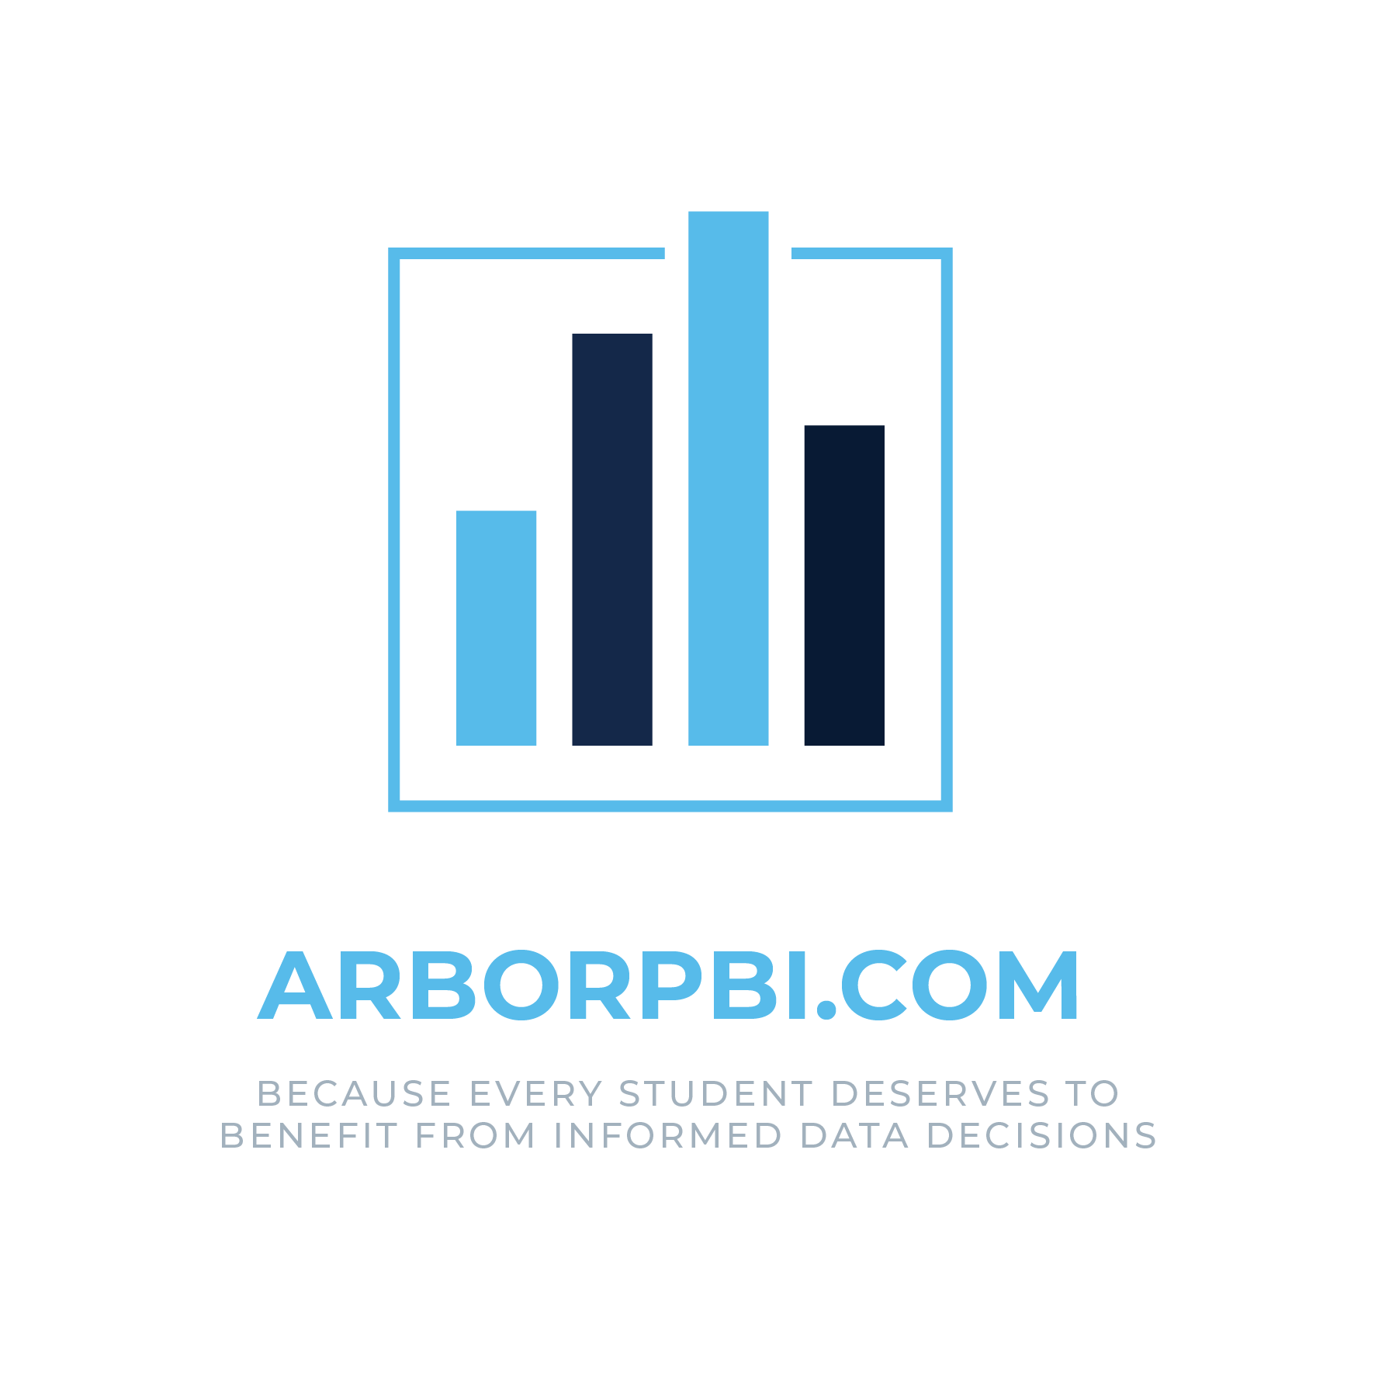

Introduction to ArborPBI.com

ArborPBI.com is an independent website that provides analytical resources, reports, dashboards, and related content designed for users of the Arbor Management Information System (MIS).
ArborPBI.com is not affiliated with, associated with, authorised by, endorsed by, or sponsored by Arbor Education Partners Limited (“Arbor”). The use of the name “Arbor” on this website is solely for the purpose of identifying compatibility with Arbor’s MIS platform and describing the intended use of the resources provided.
All trademarks, service marks, trade names, logos, and other intellectual property relating to Arbor remain the property of their respective owners. Any references to Arbor are made for informational purposes only and do not imply any relationship, endorsement, approval, or recommendation by Arbor.
ArborPBI.com is the hosting site for my ongoing Power BI project for Arbor based schools, bringing together a collection of analysis-based documentation, models, and reports. It grew from the collaborative problem-solving culture on Arbor HQ, where many of us shared examples and ideas, and where great community work can still be found today. Recognising that many schools simply don’t have the time or resources to create these tools themselves, I share these models and reports to make data more accessible and useful, because every student deserves to benefit from informed, data-driven decisions.
As this project is developed mainly in my spare time, alongside my full-time role, progress can sometimes be slower than I would like. While I may not always be able to implement new features or enhancements immediately, I do encourage feedback, suggestions, and requests from users, as these help keep the project moving forwards. Bug reports are always treated as a priority, and I try to investigate and resolve them as quickly as possible.

Contents
1. Introduction to ArborPBI.com 2
2. Introduction 4
3. Report Pages 4
3.1. Latest Data. 4
3.2. By Week 4

Introduction
This report compares data in Arbor against the published DfE data held by Arbor.
In terms of dates, data analysis is capped in line with the latest date available in the DfE Data.
The report only uses those roll call attendance rows flagged as DfE only.

Report Pages
The report pages contain a slicer for Phase and Region. The report comprises of the following pages,

Latest Data.
This page is comprised of the following:
- Min 20 Possible Marks only slicer which only applies to the table containing the PA and SA Student counts. This helps to bring school held data in line with the DfE data.
- Table with the following columns which reflect current school values.
  - Total number of Students
  - Number of PA students
  - Number of SA Students
- Cards for attendance, absence, authorised absence and Unauthorised absence. Each card displays the school value with the DfE value underneath with an indicator as to whether the school value is considered better or worse than the DfE value
- Bar chart of the schools attendance by Year Group
- Bar chart of the schools attendance by Demographic

By Week
This contains four line graphs for:
attendance
overall absence
authorised absence
unauthorised absence.
Each graph contains one line for the school and one line for the selected DfE data and shows the data over time by week commencing.

