Arbor PBI Categorical Cohort Model – User Guide

Introduction

ArborPBI.com
ArborPBI.com is the hosting site for my ongoing Power BI project for Arbor schools, bringing together resources, models, and reports that I continue to develop in my spare time. It grew from the collaborative problem-solving culture on Arbor HQ, where many of us shared examples and ideas, and where great community work can still be found today. Recognising that many schools simply don’t have the time or resources to create these tools themselves, I share these models and reports to make data more accessible and useful, because every student deserves to benefit from informed, data-driven decisions.


Contents
1. Introduction 2
1.1. ArborPBI.com 2
2. Credits 5
3. Pre-Requisites 5
3.1. Snowflake Connector 6
3.2. Power BI Desktop Editor 6
3.3. Power BI Licences 6
4. Limitations 6
4.1. Development Testing 6
4.2. Reports 6
4.3. Single Schools 6
4.4. Trusts and MATs 6
5. Configuring the Model for first use 6
5.1. Configure the Data Source 7
5.1.1. Privacy Levels Issue 7
5.2. First Synchronisation 9
5.3. SQL Approvals 9
5.4. Configure Your Term Dates 9
5.4.1. Modifying/Updating the Term Dates Table 9
5.4.2. Term Naming Conventions 10
5.4.3. DateTable Adjustment for the Number of Terms 10
5.4.4. Updating Each Academic Year 11
5.5. Configure the Lookup Tables 11
5.5.1. Viewing the tables 11
5.5.2. Editing the Tables 12
5.6. Dim_Students Table 13
5.6.1. Add Student Name 13
5.6.2. Add Student Name Exclude 13
5.6.3. Generate Year Group 13
5.6.4. Generate Key Stage 13
5.6.5. Generate Key Stage Index 13
6. Transform Checks Report Page 14
7. Additional Pages 14
7.1. Data Quality Pages 14
7.1.1. Students with Redundant Marks 14
7.1.2. Redundant Marks 14
7.1.3. Attendance Rows Missing a Linked Student 14
7.1.4. Students Never Present 14
7.1.5. Students Never Present 14
7.1.6. Attendance Data Check 14
7.1.7. Missing UPN TY 15
7.1.8. RC Student Count Check TY 15
7.1.9. RC Students with No is Possible TY 15
7.2. Template Pages 15

Credits
This project has benefited from the support, knowledge, and generosity of many members of the Arbor community.
Along the way, I have learned a great deal from the discussions, questions, answers, and shared resources posted on Arbor HQ. Many people have contributed indirectly through their willingness to share ideas, provide feedback, and help others solve problems.
There are also several individuals who took the time to engage with me personally, offering guidance, encouragement, constructive feedback, and practical support throughout the development of this model and report collection. Their input has helped shape both the technical aspects of the project and given me the confidence to see it through to completion.
While it would be impossible to thank everyone individually, I would particularly like to acknowledge the following:
- Russel Barnes, for his expertise in SQL and for patiently answering my many questions whenever I found myself stuck.
- Steve Beard and Ian Gladden, for sharing ideas, providing feedback, and offering encouragement that helped shape the earlier models and reports which ultimately evolved into this collection.
- Rob Wall, Tim Mockford, and Emlyn Harrison, whose posts, templates, screenshots, and shared knowledge on Arbor HQ provided both inspiration and practical ideas for report content and layout.
- Tim Moore, for the wealth of information he continually shares on Arbor HQ, along with the advice and feedback he has generously provided. I would highly recommend his Power BI data quality post on Arbor HQ, which includes a useful template for assessing data quality within Arbor, as well as a valuable URL feature that can open records directly within Arbor to support further investigation.
- Steve Livesey, for the many conversations, shared ideas, and code discussions that contributed to the development of this project.
- Jonathan Lloyd, for his support, encouragement, and motivation at a time when completing this project felt particularly challenging. His willingness to offer encouragement and perspective made a genuine difference and helped me keep moving forward.
- Matt Breakwell, our school's Attendance Officer, who has remained enthusiastic about exploring the potential of Power BI and has provided valuable feedback, suggestions, and feature requests throughout the project.
- Lisa Wood, my wife, whose patience and support made this project possible. Over the seven months it has taken to design, build, test, and refine this model and report collection, she has willingly given up countless evenings and weekends while I disappeared behind a screen. Her understanding and support throughout that time have been invaluable.
To everyone who has shared knowledge, provided feedback, answered questions, or simply offered encouragement along the way, thank you. Your contributions have played an important part in bringing this project to completion.

Pre-Requisites
The following Pre-Requisites are required in order to make use of this model:

Snowflake Connector
To make use of this model, you must have the Arbor Snowflake connector (which is an annually paid for add on purchased directly with Arbor).
You will need the credentials for this connection when setting up the model for first use.

Power BI Desktop Editor
You will need the Power BI Desktop editor to initially configure the model. It is advised to use the latest version of the Editor as using older versions can cause issues.

Power BI Licences
You will require Power BI licences to publish and share the associated reports with others.

Limitations
The following limitations currently apply.

Development Testing
This model was developed and tested using a single secondary school with KS3, KS4 and KS5 students as its source. Due to this, additional configuration work may be required in order to get the model to work in a MAT, Trust or lower school environment.

Reports
Currently, both the model and its associated reports only focus on Roll Call Attendance. However, the model was designed in such a way that additional analysis, such as for behaviour, can be added at a later date.

Single Schools
If you are a single secondary school, this should hopefully work with minor changes. Areas that may cause an issue are Year Groups and Terms. If you break the year into 6 terms rather than 3 then you will also need to tweak some of the settings.

Trusts and MATs
If you are a trust, this may prove more challenging due to issues between schools such as:
- Differing naming conventions for year groups
- Different Naming conventions for form groups
- Different term names
- Different calendars
Due to this, in the first instance so you may want to evaluate this against a single school and then transfer the measures and visuals you find useful to your existing trust model.

Configuring the Model for first use
The following steps take you through how to configure the model for first use.

Configure the Data Source
Import the template into your Power BI Editor.
After the import you may say a message indicating that it was unable to connect to the data source, this is normal and expected.
After importing the template into the Power BI editor, in the main ribbon menu ensure you are on the Home menu and then navigate to Transform Data > Data Source Settings
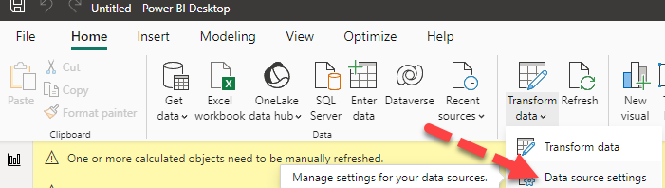
When the Data Source settings are displayed, click on the snowflake connector and then click on edit permissions.
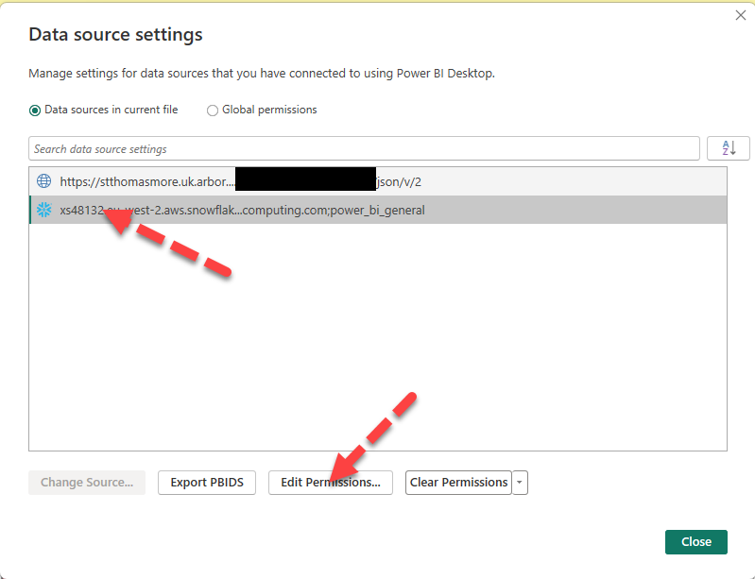
On the next screen click on the edit button. At this point you need to enter the connection credentials for your snowflake connector (as supplied by Arbor).

Privacy Levels Issue
If after doing the above you get a warning in relation to privacy levels then please try the following steps which should hopefully resolve the issue.
In the main ribbon menu ensure you are on the Home menu and then navigate to Transform Data > Data Source Settings
When the Data Source settings are displayed, click on the snowflake connector and then click on edit permissions.
You can then make privacy permission changes via the following screen if required:
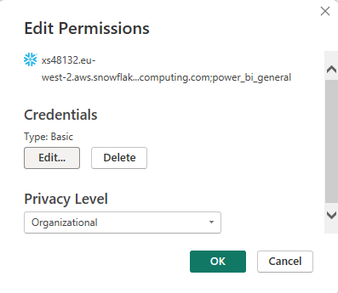

First Synchronisation
Once the template is loaded and the connection configured, you can then refresh the template, and your data should be pulled in. The first time you refresh, this may generate a dependencies error. This is normal and if you refresh again a couple of times this should clear, and the refresh should complete (may take up to 20 mins). This is because Power BI can try and load more than one table at a time which can cause issues if a table relies on another table that hasn’t yet loaded.
Another way to address these first synchronisation issues is to navigate to the transform view and under refresh preview, click on refresh all and when that completes, close and apply changes.

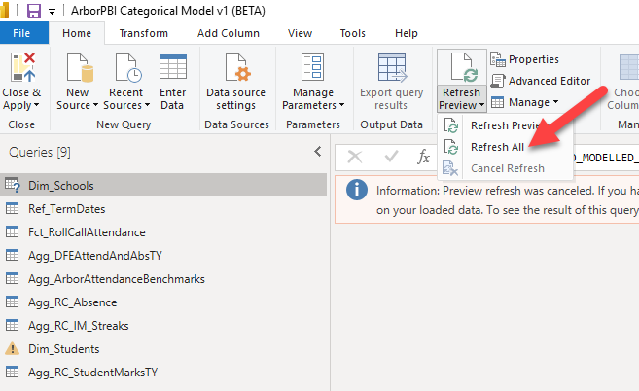

SQL Approvals
SQL has been used in a number of queries to limit the data that is pulled in via the snowflake. You may be prompted to approve these so that they can run but you should hopefully only have to do this once per query.

Configure Your Term Dates
You will need to manually update the Ref_TermDates table to reflect your specific term dates.
In addition to this initial configuration, you will also need to update the table for each new academic year.
IMPORTANT: As the DateTable makes use of this table, you should ensure the Ref_TermDates table is correct prior to checking the DateTable.

Modifying/Updating the Term Dates Table
In the Power BI Editor, switch to transform view. To modify the Term Dates table, first select it by clicking on it in the query list (1) and then click on the cog icon in the source applied steps (2):
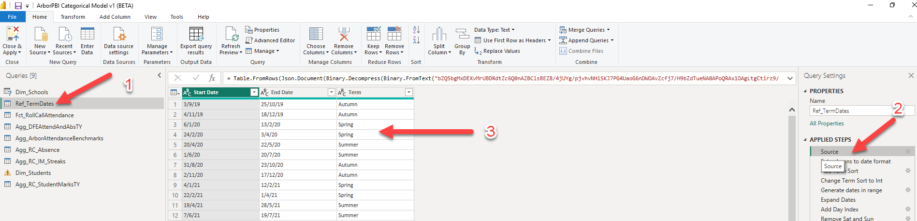
This will open the Create Table view (3).
From here you can make the changes you want and then click on OK to save the changes (note that in the screen shot above, all 6 half terms are listed but only three different term names are used (for a 3 term approach).

Term Naming Conventions
This table supports 3 or 6 terms per year with the following naming conventions, use of any other names will break the DateTable:
Autumn
Autumn 1
Autumn 2
Spring
Spring 1
Spring 2
Summer
Summer 1
Summer 2
IMPOTANT: Even if you run on three terms, you must add the 6 sets of term dates into this table in order to correctly identify term time days. If you do not, then the mid-term breaks will count as term time days.

DateTable Adjustment for the Number of Terms
The Term Selection column in the DateTable evaluates This Term Previous Year by using the number of terms per year. The default is 3. If you use half terms, you will need to edit the DAX code for the Term Selection column in the DateTable and change the value from 3 (highlighted) to 6:
Term Selection =
VAR LastTermNameIndex= SELECTEDVALUE (Ref_YearRelatedDateInfo[Last Term Name Index TY])
VAR CodeDifference = LastTermNameIndex - DateTable[Term Name Index]

RETURN
SWITCH(
CodeDifference,
0, "This Term",
1, "Previous Term",
// If you have 3 terms per year then use 3 in the line below, if you have 6 terms per year then use 6 in the line below.
3, "This Term Previous Year",
LastTermNameIndex,"",
"Older Terms"
)

Updating Each Academic Year
For each new academic year, you will need to add in the associated term dates, and you have two options for this:
- Update the dates on the oldest year in the table to reflect the new dates. This approach would normally be carried out after the last term time date of the current academic year and before the start of the new academic year.
- Add in new rows for the new year and then remove the rows for the older years once they are no longer required. This is the more flexible approach and allows you to add next year’s dates in as soon as you have them, and you can then remove the oldest year’s data once the next academic year has started.

Configure the Lookup Tables
This model contains lookup tables for:
- Absence Bands
- Attendance Bands
- Marks to Leave Bands
Tip: These are all prefixed with Lkp_ to aid identification

Viewing the tables
If you select table view in the Power BI Editor and then click on the table name, the table will be displayed at the bottom of the screen and will look similar to this:
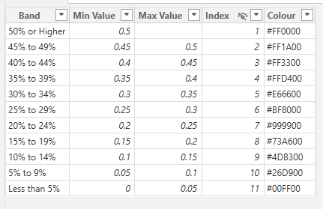

Although the column names may vary, they generally contain a name for the band, a sort index, a min value, a max value and a colour code.
In terms of the bands, you may notice that the Min value in one row may appear as the max row in another row. It is important to note that these bands are not overlapping and each row is evaluated using the following logic:
If a value is >= to the Min Value AND < Max Value then the row is considered a match,

Editing the Tables
If you wish to change these values, you can edit the code for the table by clicking on the table name and then edit the relevant values in the associated code. An example of a table’s code is provided below:
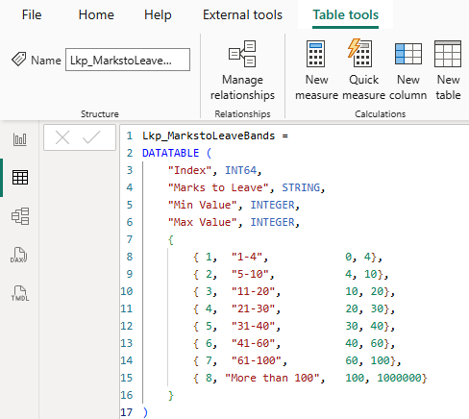

Dim_Students Table
The table was based on the built in Arbor STUDENTS table. However, several transforms are used to customise it for use in this report.
Some assumptions are made with these transforms and if these are not met in the underlying data, then this may cause loading issues. This will be made worse if you are analysing trust data and there is an inconsistent naming convention across schools. In this case you may need to further transform the data in this table.
The transform steps you may need to look at or modify are:

Add Student Name
This is built by appending the form group to the name. It is separated from the Student Name Exclude column as this is intended to be used to include students from analysis. Using one student name for both makes it difficult to synchronise slicers between pages if they are being used for different objectives.
This is built by appending the form group to the name. If the form group name is particularly long you may want to replace this with something shorter so that in the report visuals, the student name field does not become too large causing the need to scroll within visuals. By including some form of year group and from identifier in the student’s name field, you negate the need to add dedicated year group and from group columns in your visuals, saving space in your report and also avoid those groups potentially affecting your row level calculations.

Add Student Name Exclude
This is built by appending the form group to the name. It is separated from the Student Name column as this is intended to be used to exclude students from analysis. Using one student name for both makes it difficult to synchronise slicers between pages if they are being used for different objectives.
If the form group name is particularly long you may want to replace this with something shorter so that in the report visuals, the student name field does not become too large causing the need to scroll within visuals. By including some form of year group and from identifier in the student’s name field, you negate the need to add dedicated year group and from group columns in your visuals, saving space in your report and also avoid those groups potentially affecting your row level calculations.

Generate Year Group
This transform attempts to standardise the Year Group name by looking at for numbers or specific text in the year groups imported from Arbor. You may need to modify this transform if your Year Groups differ from that expected.

Generate Key Stage
This generates a Key stage based on the Year Group Index. You may want to change these ranges as well as add additional Key Stages as by default, it only covers KS3, KS4 and KS5.

Generate Key Stage Index
This generates a Key stage Index based on the Year Group Index. You may want to change these ranges as well as add additional Key Stage Indexes as by default, it only covers KS3, KS4 and KS5.

Transform Checks Report Page
The model contains some built-in report pages, one of which is the Transform Checks page. You can use this to see if the transforms are working correctly. If they are working correctly, you should see something like this:
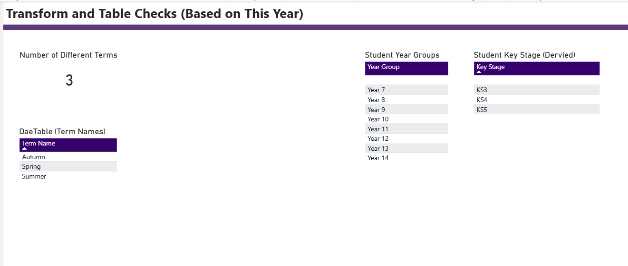

Additional Pages
The model contains some additional pages as detailed below:

Data Quality Pages
These pages are used to check the quality of the underlying data.

Students with Redundant Marks
Identifies those students with redundant roll call marks this year

Redundant Marks
Identifies redundant roll call marks by year

Attendance Rows Missing a Linked Student
SQL is used to create the attendance rows and also pulls in some student related data (Date of Birth) to enable the setting of the DfE flag. Due to this it is possible for rows to be present in the attendance table with no matching student (DOB will be blank as will DfE flag). This initially caused an error but has now been addressed in the SQL code itself. However, it may still be helpful to identify such records and this table attempts to do that.

Students Never Present
List on roll students who have never had a present roll call attendance mark. This is more advisory than confirmation of an actual underlying error.

Students Never Present
Lists students who have a Sex record of Not Known

Attendance Data Check
This page is used to identify a potential synchronisation issue. It will show the lower date in red if it believes the data in the report is out of date compared to what should be in Arbor.

Missing UPN TY
Lists students who are flagged as being on roll this year but who have no UPN.

RC Student Count Check TY
This is more advisory than confirming a definite error. It identifies the number of students with roll call attendance records this year and counts those with at least one Is Possible mark and those with none

RC Students with No is Possible TY
Lists those students who have no IS Possible marks in this year’s roll call attendance table.

Template Pages
The template pages do not show any data by design. They are included purely as layout templates for reports so that the user can cut and paste them into new report pages to ensure consistency with the existing reports.

